Abstract
The impact of decision difficulty on search behavior depends on the relative accessibility of maximize accuracy and minimize effort goals in memory. The default assumption, derived from constructive choice theory, is that maximize accuracy and minimize effort goals are both accessible. Thus, the two goals compete to influence a decision process. When this is the case, an increase in decision difficulty discourages search and the opportunity to make an accurate decision suffers. The alternative assumption, derived from goal systems theory, is that maximize accuracy and minimize effort goals can be differentially accessible. When one of these goals is more accessible, decision difficulty signals poor goal progress and reduces goal pursuit. That is, when a maximize accuracy (minimize effort) goal is more accessible, decision difficulty reduces (increases) search. Six studies show that goal systems theory holds when a maximize accuracy or minimize effort goal is more accessible, i.e., is deliberately pursued. The results have implications for how decision difficulty influences information search, satisficing, and choice quality.

Keywords: maximize accuracy, minimize effort, decision difficulty, goal systems theory, information search

Julia, Mike, and their two children love to travel, especially on getaway weekends. One evening, Mike says he would like to get away next weekend. He asks Julia to find a luxurious but economical destination. Julia thinks that luxurious and economical is a lot harder to find than luxurious and fun, their typical type of vacation, but why not? Mike also reminds Julia that she needs to be efficient, since the booking needs to be done right away. Our research investigates how Mike’s request to find a luxurious and economical instead of a luxurious and fun destination influences how many vacation destinations Julia considers before making her decision. Will the increased difficulty of the decision encourage Julia to search more or less? Further, if Mike had asked Julia to make a careful decision (i.e., be accurate), rather than being efficient, would making the decision harder have resulted in Julia searching more or less? Finally, what if Mike had not mentioned either efficiency or accuracy?
Alternative models of consumer choice suggest that there are two different ways an increase in decision difficulty can influence the number of destinations Julia considers. First, goal systems theory (which applies when efficiency or accuracy goals are explicitly mentioned) predicts that making a decision more difficult should reduce the pursuit of a focal decision process goal (Huang & Zhang, 2011). If Julia’s goal is to be more efficient, increased decision difficulty should signal a lack of progress toward the efficiency goal and result in more search. If Julia’s goal is to be more accurate, increased decision difficulty should signal a lack of progress toward the accuracy goal and result in less search. Thus, an increase in decision difficulty frustrates the pursuit of the focal decision process goal so that Julia is less efficient or accurate than she otherwise would have been. Second, the constructive choice model (which would apply in the case where Mike does not mention either efficiency or accuracy) predicts that making a decision more difficult should result in Julia searching less (Bettman, Luce, & Payne, 1998). The more difficult the decision process, the fewer options Julia should want to consider.
Our research provides support for the goal systems theory predictions when a decision process goal is deliberately pursued (e.g., Mike explicitly asks Julia to be efficient or be accurate). Six experiments show that an increase in decision difficulty decreases the pursuit of an efficiency goal (thus leading to more search) or an accuracy goal (thus leading to less search). Likewise, an increase in decision ease increases the pursuit of an efficiency goal (thus leading to less search) or an accuracy goal (thus leading to more search). Alternatively, when decision process goals are naturally pursued (e.g., Mike does not mention efficiency or accuracy), search was consistent with the predictions of the constructive choice model (see experiment 6). There was less search under increased decision difficulty and more search under decreased decision difficulty. Collectively, these results imply that goal systems theory accounts for the influence of decision process goals on decision making when one decision process goal is relatively more accessible (i.e., the effort and accuracy goals are not competing), whereas constructive choice theory accounts for the influence of decision process goals on decision making when multiple goals are accessible (i.e., the effort and accuracy goals are competing). These results are important, because constructive choice theory is typically used to explain the influence of decision process goals (e.g., be efficient, be accurate) on choice behavior.
Information Search
Sequential, Stimulus-Based Search
Julia is engaging in sequential, stimulus-based search (Ratchford & Srinivasan, 1993). Sequential, stimulus-based search involves considering a series of options, one after the other, until a choice is made (Grether & Wilde, 1984; Häubl, Dellaert, & Donkers, 2010). The amount of search depends on the costs and benefits of considering additional alternatives (Adam, 2001; Zwick, Rapoport, & Muthukrishnan, 2003). One factor that influences the cost of search is decision difficulty, defined as the amount of computational effort required to make a decision (e.g., it is more difficult for Julia to find a luxurious and economical destination than a luxurious and fun destination). Decisions become more difficult when conflicting benefit goals make it difficult to find a dominating option (Seale & Rapoport, 1997), when negatively correlated attributes make it difficult to compare options (Bettman et al., 1993; Johnson, Meyer, & Ghose, 1989), and when the amount of available information becomes overwhelming (Wright, 1975).
Decision Difficulty and Constructive Choice Theory
Constructive choice theory accounts for how people engage in natural decision making, as Julia would have done in the absence of Mike’s request that she be efficient. Constructive choice theory proposes that decision quality and information search depend on two decision process goals; minimize effort and maximize accuracy (Bettman et al., 1998). Constructive choice theory assumes that the minimize effort and maximize accuracy goals are both accessible, so that people trade-off these competing goals when creating a choice strategy preference function (see lines in figure 1). The preference function reflects the weight on the effort goal relative to the accuracy goal, with a steeper slope indicating more emphasis on minimizing effort. People use decision strategies (e.g., weighted adding, lexicographic, elimination-by-aspects) that are above their preference function to make their choice.
Constructive choice theory proposes that decision difficulty impacts search behavior in two ways. First, decision difficulty shifts the preference function (see figure 1, movement from the grey line to the black line). As a decision environment becomes more difficult, people search for less information (Johnson et al., 1989; Shugan, 1980). Second, decision difficulty influences the trade-off between the minimize effort and maximize accuracy goals (see figure 1). When information is difficult to use, it discourages effort, so the emphasis on the maximize accuracy goal goes down relative to the emphasis on the minimize effort goal (i.e., the slope of the effort-accuracy preference function becomes more negative ‒ compare the black line to the grey line in figure 1). This could alter the choice strategy. For example, Julia could go from weighted adding when the decision is easy (e.g., searching for a luxurious and fun destination) to elimination-by-aspects when the decision is difficult (e.g., searching for a luxurious and economical destination), with the latter choice strategy resulting in less search.
Decision Difficulty and Goal Systems Theory
Goal systems theory accounts for how people pursue benefit goals, as exemplified by Julia’s desire to find a luxurious and economical destination. Goal systems theory proposes that each benefit goal is a desirable outcome that is represented in a semantic knowledge structure (Kruglanski et al., 2002; van Osselaer and Janiszewski, 2012). Goals are attained using means. The more (less) effective a means is for pursuing a goal, the more (less) progress a person makes toward the goal and the more (less) likely a person is to pursue the goal using those means (Huang & Zhang, 2011). For example, if Julia’s search identifies one destination with a restaurant that is definitely luxurious and economical, and a second location with a hotel that is somewhat luxurious and economical, then the restaurant will determine the vacation destination, since it is the most effective means for the goal of finding a luxurious and economical destination. Alternatively, if Julia’s search reveals hotels and restaurants that are luxurious but not economical, or economical but not luxurious, she will probably abandon one of the benefit goals and try to book a different type of vacation destination (e.g., luxurious and fun).
To date, goal systems theory has not been used to investigate how decision difficulty and decision process goals (e.g., minimize effort, maximize accuracy) impact search behavior. Yet, the goal systems perspective is valuable because it makes an assumption that is at odds with constructive choice theory. Namely, goal systems theory assumes all goals are independently represented in a semantic knowledge structure. Further, goals are pursued using means. For example, a maximize accuracy goal is pursued using means such as valuing attributes, weighting and integrating attribute information, evaluating alternatives, and comparing new alternatives to existing favorites in order to make a normative decision (e.g., choice of a utility-maximizing alternative). Conversely, a minimize effort goal is pursued using means such as valuing attributes, comparing attribute values, eliminating alternatives, and retaining alternatives that surpass a threshold (e.g., choice of an acceptable option). The effectiveness of the goal pursuit should depend on how decision difficulty impacts the use of these means.
Goals systems theory predicts that increasing decision difficulty will make it harder to execute the means used to pursue a decision process goal. If the decision process goal is to maximize accuracy, as when Mike asks Julia to make a careful decision, then increasing decision difficulty (e.g., searching for a luxurious and economical destination) should frustrate goal pursuit, and Julia should search less (see the black line in the maximize accuracy condition of figure 1) relative to when no destination benefits are specified (see the white bar in the maximize accuracy condition of figure 1). This should occur because it becomes harder to set attribute weights in a compensatory choice strategy, or prioritize attributes in a non-compensatory choice strategy, and determine if a specific choice strategy is helping one progress toward a desired outcome (Broniarczyk & Griffin, 2014). Consequently, people should feel uneasy/uncertain about the decision process (Kardes et al., 2007; Muthukrishnan, 1995). Similarly, if the decision process goal is to minimize effort, as when Mike asks Julia to make an efficient decision, then increasing decision difficulty should frustrate goal pursuit and Julia should search more (see the black bar in the minimize effort condition of figure 1) relative to when no destination benefits are specified (see the white bar in the minimize effort condition of figure 1). Again, the lack of goal progress makes people feel uneasy/uncertain about the decision process. Thus, for increased goal difficulty goal systems theory predicts
H1: When the decision process goal is to maximize accuracy, an increase in decision difficulty will decrease search relative to a baseline control group.
a. The influence of decision difficulty on search is mediated by decision uncertainty.
H2: When the decision process goal is to minimize effort, an increase in decision difficulty will increase search relative to a baseline control group.
a. The influence of decision difficulty on search is mediated by decision uncertainty.
Goals systems theory makes complementary predictions for increasing decision ease. Increasing decision ease makes it easier to execute the means used to pursue a decision process goal. If the goal is to maximize accuracy, then increasing decision ease (e.g., searching for a luxurious and fun destination) should facilitate goal pursuit, and Julia should search more (see the grey bar in the maximize accuracy condition of figure 1) relative to a baseline condition. This should occur because it becomes easier to establish guidelines within a choice strategy, determine if a choice strategy is helping one progress toward a desired outcome, and decide whether to retain a choice strategy (Novemsky et al., 2007; Saad & Russo, 1996). Consequently, people should feel more confident/certain about the choice process (Moorthy et al., 1997; Saad & Russo, 1996) and try to maximize accuracy by searching more. Similarly, if the decision process goal is to minimize effort, then increasing decision ease should facilitate goal pursuit, and Julia should search less (see the grey bar in the minimize effort condition of figure 1), relative to a baseline condition. Again, the ease of goal progress makes people feel confident/certain about the choice process. Thus, for increased goal ease, goal systems theory predicts
H3: When the decision process goal is to maximize accuracy, an increase in decision ease will increase search relative to a baseline control group.
a. The influence of decision ease on search is mediated by decision certainty.
H4: When the decision process goal is to minimize effort, an increase in decision ease will decrease search relative to a baseline control group.
a. The influence of decision ease on search is mediated by decision certainty.
We propose that goal systems theory accounts for the influence of decision difficulty on search behavior when a minimize effort or maximize accuracy goal is deliberately pursued, as is the case when Mike asks Julia to be efficient or careful. Given that the predictions of goal systems theory are novel, we present five studies testing the predictions of goal systems theory. Our sixth study directly manipulates whether decision process goals compete versus not, showing that constructive choice theory accounts for the results when goals compete. We attribute these results to a single goal being relatively more accessible, and the other goal not competing, when one of the decision process goals is deliberately pursued, but the two goals being similarly accessible, and competing, when a decision process goal is not deliberately pursued.
Study Details
Eight studies were used to investigate the hypotheses. The methodological detail appendix (henceforth MDA) reports all stimuli, materials, manipulations, and the sample size determination. The MDA also includes all pretests, manipulation checks, means and standard deviations for each condition of each experiment, and product replicate analyses (when applicable). The raw data, code files, and variable list for all experiments, including pretests and ancillary studies, are available at the Open Science Framework (https://osf.io/276gs/).
Experiment 1
Experiment 1 tested the idea that decision difficulty influences the amount of search when people are deliberately pursuing a maximize accuracy or minimize effort goal (hypotheses 1 and 2), consistent with goal systems theory. The context was a sequential search for a vacation package or a car. We anticipated that making a search more difficult, by asking a participant to consider a trade-off between conflicting benefit goals, would decrease search when the goal was to maximize accuracy (H1) but increase search when the goal was to minimize effort (H2).
Method
Participants and design. Participants were 200 undergraduate students from a U.S. university who participated in exchange for course credit. The design was a 2 (decision process goal: maximize accuracy vs. minimize effort) x 2 (decision difficulty: baseline vs. difficult) x 2 (product replicate: vacation package, car) mixed design. Product replicate was manipulated within-subjects. The dependent measures were the number of options considered, choice of the best option considered, and use of a satisficing strategy – choice of the last option considered. The latter two measures have been used as indicators of maximizing accuracy and minimizing effort in prior research (Creyer, Bettman, and Payne, 1990; Simon, 1955; Stüttgen, Boatwright, & Monroe, 2012).
Procedure and stimuli. Participants were told they would take part in three studies about how consumers make choices. First, participants engaged in the sequential search task training procedure (MDA A). After this task, participants proceeded to the purported first study, designed to manipulate the decision process goal (MDA B); they were asked to list three reasons why it is important to be accurate when making choices (maximize accuracy goal) or three reasons why it is important to put less effort into making choices (minimize effort goal). Direct instruction (Creyer et al., 1990; Hong & Chang, 2015) and listing reasons (Briley, Morris, & Simonson, 2000; Simonson & Nowlis, 2000) are commonly used to activate decision process goals.
Next, participants read instructions for the purported second study, designed to manipulate decision difficulty (MDA C). Participants in the difficult condition were asked to make their decision using conflicting benefit goals. Conflicting benefit goals have been shown to make information gathering (Etkin, Evangelidis, & Aaker, 2015), information processing (Dhar, 1997), and the expression of one’s preferences (Valenzuela, Dhar, & Zettelmeyer, 2009) more difficult. For this study, the conflicting benefit goals were prestige and thrift (see pretests in MDA F). Participants in the baseline condition were asked to do an unrelated intervening task designed to take a similar amount of time and effort: “This study aims to investigate people's cognitive ability. In the box below, list as many words as possible with the letter ‘e’ in the middle. For example, ‘apartment’ or ‘water’.” This task allowed people to use their personal benefit goals in the choice task and hence should not influence decision difficulty.
Next, participants were directed to the purported third study involving the choice tasks for vacation packages and cars. Participants saw two options and a third box providing an opportunity to see another option. Each time the participant clicked the “Look at another option” button, a new option would appear, along with the previously displayed options. The order of option presentation was a random draw from the 15 options. The options were selected using a pretest of options collected from the web. For each replicate, the options had a similar level of attractiveness, so that there were not objectively dominant or dominated options. Please see MDA D for the complete stimuli and MDA E for additional information about the sequential search task. The actual choice shares of options did not vary by condition (see MDA F for choice shares per condition and additional information).
After each of the two choice tasks, participants indicated how focused they were on (1) being accurate and (2) minimizing effort using two 9-point scales (1 = not at all focused, 9 = very focused). Finally, after these manipulation check measures, participants were asked to rank order the 15 options in each category by selecting and ranking the five least appealing, then selecting and ranking the five most appealing, and then ranking the remaining (middle) options. During the ranking procedure, participants were able to see all available options for both product replicates (one replicate at a time). This procedure enabled us to compare participants’ selected options to the post-choice option ranks. Choosing a top-ranked (i.e., best) option for a given choice set is indicative of choice quality/accuracy. We counterbalanced the product replicates (cars vs. vacation packages) in the main study and ranking task.
Results
Manipulation checks. The decision process goal manipulations successfully encouraged participants to be accurate (M_{accuracy} = 7.43, SD_{accuracy} = 1.63; M_{effort} = 5.90, SD_{effort} = 2.40; F(1, 196) = 27.12, p < .001, $\hat{ω}$_{p}² = .12) and minimize effort (M_{accuracy} = 2.86, SD_{accuracy} = 1.91; M_{effort} = 5.17, SD_{effort} = 2.35; F(1, 196) = 59.21, p < .001, $\hat{ω}$_{p}² = .23) (see MDA F).
Number of options considered. An ANOVA revealed a significant process goal by decision difficulty interaction (F(1, 196) = 10.80, p = .001,$\hat{ω}$_{p}² = .05; see figure 2). Consistent with prior literature, the maximizing accuracy goal (M = 9.07) resulted in more search than the minimize effort goal (M = 4.63) in the baseline condition (F(1, 196) = 27.39, p < .001,$\hat{ω}$_{p}² = .12). Consistent with hypotheses 1 and 2, an increase in decision difficulty decreased the number of options considered in the maximize accuracy condition (M_{baseline} = 9.07, M_{difficult} = 7.24; F(1, 196) = 4.74, p = .031,$\hat{ω}$_{p}² = .02), but increased the number of options considered in the minimize effort condition (M_{baseline} = 4.63, M_{difficult} = 6.72; F(1, 196) = 6.10, p = .014,$\hat{ω}$_{p}² = .03).
Evidence for process: choice quality and satisficing. An analysis of choice quality (choice of best option) in the maximize accuracy condition and satisficing (choice of last option considered) in the minimize effort condition was used to provide further support for the hypothesis that decision difficulty reduced the pursuit of the decision process goals. We calculated two indices – a choice quality index and a satisficing index – that represented the number of choices of the best (last) option considered in both replicates. Consistent with our account, participants with a maximize accuracy goal were less likely to pick their best option when the decision became more difficult (p_{baseline} = 1.49, p_{difficult} = 1.21; F(1, 196) = 3.94, p = .05,$\hat{ω}$_{p}² = .014) and participants with a minimize effort goal were less likely to pick the last option considered when the decision became more difficult (p_{baseline} = .67, p_{difficult} = .35; F(1, 155) = 5.72, p = .018,$\hat{ω}$_{p}² = .03). More detailed analyses of these measures are presented in MDA F.
Alternative Explanations: Demand Effect and Process Goal Abandonment
Experiment 1 used a transparent manipulation of the decision process goals. This created the possibility of hypothesis guessing and demand effects. To address this issue, 169 undergraduate students participated in the experiment 1 procedure up to the point at which the first two cars (vacations) were considered. Participants were then asked how many additional cars (vacations) they planned to view. Unlike the results presented in figure 2, there was no process goal by decision difficulty interaction (F(1, 165) = .00, p = .97). The results showed a main effect of the decision process goal (M_{accuracy} = 9.86, SD = 3.92, M_{effort} = 4.60, SD = 1.78; F(1, 165) = 122.27, p < .001,$\hat{ω}$_{p}² = .42), but no main effect of decision difficulty (M_{baseline} = 7.50, SD = 4.11, M_{difficult} = 6.93, SD = 3.49; F(1, 165) = .56, p = .46). These results are not consistent with an explanation based on hypothesis guessing or demand.
Another alternative explanation is that decision difficulty led to abandonment of the decision process goals. According to this explanation, decision process goal pursuit was reduced (i.e., less search on maximize accuracy and more search on minimize effort) because decision difficulty made people disengage from the decision process goal. If abandonment occurred, there should have been an interaction on the decision process goal manipulation check indicating that participants in the difficult decision condition were less focused on being accurate or minimizing effort, depending on the condition. We did not observe this result (see MDA F).
Discussion
Experiment 1 provides evidence that the deliberate pursuit of a maximize accuracy or minimize effort goal is undermined by decision difficulty (H1 and H2). Participants searched less when they deliberately pursued a maximize accuracy goal, but more when they deliberately pursued a minimize effort goal. We contend that decision difficulty made it harder to execute the means (processes) used to pursue the maximize accuracy or minimize effort goals, as evidenced by the amount of search, selection of the best option (choice quality), and selection of the last option considered (satisficing). Critically, decision difficulty decreased accuracy when participants pursued a maximize accuracy goal and decreased satisficing when they pursued a minimize effort goal.
These results are inconsistent with the predictions of the constructive choice model, which are that decision difficulty should lead to less search in both decision process goal conditions (Johnson et al., 1989). Note that the constructive choice model can also be used to predict that decision difficulty will lead to increased search (Bettman et al., 1993; Dhar, 1997; Tversky & Shafir, 1992), but it does not predict anything other than a main effect of decision difficulty on search due to its assumption that accuracy and effort goals trade-off.
Experiment 2
Experiment 2 tested the idea that decision ease can facilitate the pursuit of decision process goals (hypotheses 3 and 4). The procedure was identical to that used in experiment 1, except that complementary benefit goals were used to make the decision easier (Dieckmann & Rieskamp, 2007; Wilks, 1938). We anticipated that making a decision easier would increase search when the goal was to maximize accuracy (H3) but decrease search when the goal was to minimize effort (H4).
Method
Participants, design, and procedure. Participants in experiment 2 were 446 U.S. MTurk workers who were paid $1.20 to participate in a 2 (decision process goal: maximize accuracy vs. minimize effort) x 2 (decision ease: baseline vs. ease) x 2 (product replicate: vacation package, car) mixed design. The complementary benefit goals in the decision ease condition were prestige and fun (see MDA F for the pretest). Except for this change, the procedure was identical to that used in experiment 1.
Results
Manipulation checks. The decision process goal manipulations successfully encouraged participants to be accurate (M_{accuracy} = 7.93, SD_{accuracy} = 1.13; M_{effort} = 6.95, SD_{effort} = 2.01; F(1, 442) = 39.99, p < .001, $\hat{ω}$_{p}² = .08) and minimize effort (M_{effort} = 6.41, SD_{effort} = 2.20; M_{accuracy} = 4.00, SD_{accuracy} = 2.80; F(1, 442) = 101.67, p < .001, $\hat{ω}$_{p}² = .18) (see MDA G).
Number of options considered. An ANOVA revealed a significant decision process goal by decision ease interaction (F(1, 442) = 13.62, p < .001,$\hat{ω}$_{p}² = .03; see figure 3). Consistent with hypotheses 3 and 4, decision ease increased the number of options considered in the maximize accuracy condition (M_{baseline} = 8.64, M_{ease} = 10.16; F(1, 442) = 8.08, p = .005,$\hat{ω}$_{p}² = .02), but decreased the number of options considered in the minimize effort condition (M_{baseline} = 4.87, M_{ease} = 3.60; F(1, 442) = 5.65, p = .018,$\hat{ω}$_{p}² = .01).
Evidence for process: choice quality and satisficing. An analysis of choice quality and satisficing provided further support for the hypothesis that decision ease increased the pursuit of the decision process goals. As in experiment 1, we calculated two indices – a choice quality index and a satisficing index – that represented the number of choices of the best (last) option considered in both replicates. Participants with a maximize accuracy goal were more likely to pick the best option in the decision ease condition (p_{baseline} = 1.13, p_{ease} = 1.53; F(1, 442) = 16.14, p < .001,$\hat{ω}$_{p}² = .04) and participants with a minimize effort goal were more likely to pick the last option considered in the decision ease condition (p_{baseline} = .49, p_{ease} = 1.12; F(1, 344) = 91.51, p < .001,$\hat{ω}$_{p}² = .21). More detailed analyses of these measures are presented in MDA G.
Discussion
Experiment 2 provides evidence that the deliberate pursuit of a maximize accuracy or minimize effort goal is facilitated by decision ease (H3 and H4). We contend that decision ease made it easier to execute the means (processes) that supported the pursuit of the maximize accuracy or minimize effort goals. Decision ease increased choice quality when there was a maximize accuracy goal and increased satisficing when there was a minimize effort goal. Finally, the results are not consistent with the constructive choice model prediction that decision ease should lead to more search in both decision process goal conditions.
Experiments 3a and 3b
Experiments 3a and 3b were designed with three purposes in mind. First, we tested the idea that decision uncertainty mediated the relationship between decision difficulty and search (hypotheses 1a and 2a). Second, experiment 1 used a no-explicit-goal baseline control group in the decision difficulty factor. This control group represented a natural decision context. However, from an internal validity perspective, a more appropriate control group behavior might be to pursue one of the two conflicting benefit goals used to create decision difficulty. This would address ambiguity about what participants in a no goal, baseline control group were doing in prior studies. This would also allow us to confirm that there is nothing peculiar about the conflicting benefit goals. Third, four alternative explanations were addressed: process accountability, outcome accountability, decision importance, and involvement with the choice task, as each of these processes have been shown to influence pursuit of a decision process goal (Bettman et al., 1998; McAllister et al., 1979; Tyszka, 1998; Zhang & Mittal, 2005).
Design and Method
The design and method for experiments 3a (maximize accuracy goal) and 3b (minimize effort goal) were identical. Thus, we discuss the procedures concurrently.
Participants and design. MTurk workers were paid $1.20 to participate in experiments 3a (n = 196) and 3b (n = 204). The mixed-design was a 4 (decision difficulty: baseline – no goal vs. baseline - one goal [prestige] vs. baseline - one goal [thrift] vs. difficult - two conflicting goals [prestige and thrift]) x 2 (product replicate: vacation package, car). Decision difficulty was a between-subject factor and the product replicate was a within-subject factor. Participants in experiment 3a (3b) pursued a maximize accuracy (minimize effort) goal.
Procedure. The procedure was similar to the previous studies. Participants completed the sequential search training task (MDA A), read the decision process goal activation instructions (MDA B), and were randomly assigned to a decision difficulty condition. Participants in the baseline – no goal condition did the e-location filler task discussed in prior studies. Participants in the baseline - one goal condition were asked to pursue a single benefit goal (prestige or thrift). Participants in the difficult condition were asked to pursue two conflicting benefit goals (prestige and thrift) (MDA C). Then, participants proceeded to the vacation package and car choice tasks.
After each choice task, we measured the manipulation check and mediator. Decision difficulty (manipulation check) was measured by asking participants: “Please indicate your opinion about the car (vacation package) decision task” using a four-item, nine-point semantic differential scale: “very easy/very difficult,” “not problematic at all/very problematic,” “very simple/very complex,” “not complicated at all/very complicated” (α_{3a} = .97; α_{3b} = .97) (Laroche et al., 2005). Decision uncertainty (mediator) was measured using three nine-point Likert items: “I would describe myself as indecisive during the car (vacation package) choice,” “I was struggling with the decision about the cars (vacation packages),” “I felt uncertain about what to choose” [1 = Strongly Disagree, 9 = Strongly Agree] (α_{3a} = .94; α_{3b} = .91) (Kardes et al., 2007). Four alternative-hypothesis mediators were measured: process accountability, outcome accountability, decision importance, and involvement with the choice task. None of the alternative mediators accounted for the effect of decision difficulty on search. Please see MDA E for specific details, measures, and analyses.
Experiment 3a Results: Maximize Accuracy Goal
Manipulation checks. Perceived decision difficulty was higher in the difficult – two conflicting goals condition (M = 5.58, SD = 2.38) than in the two baseline - one goal conditions (M_{prestige} = 2.92, SD_{prestige} = 1.45; M_{thrift} = 3.31, SD_{thrift} = 1.60; (F(1, 192) = 64.85, p < .001, $\hat{ω}$_{p}² = .25) and baseline – no goal condition (M = 3.13, SD = 1.52; F(1, 192) = 48.09, p < .001, $\hat{ω}$_{p}² = .20) (see MDA H).
Number of options considered. There was a significant influence of the decision difficulty manipulation on the number of options considered (F(3, 192) = 6.88, p < .001,$\hat{ω}$_{p}² = .08; see figure 4). First, participants in the difficult – two conflicting goals condition (M = 6.34) considered fewer options than participants in the baseline - one goal conditions (M_{prestige} = 9.31, M_{thrift} = 9.65; (F(1, 192) = 16.22, p < .001,$\hat{ω}$_{p}² = .07) and baseline – no goal condition (M = 9.91; (F(1, 192) = 15.75, p < .001,$\hat{ω}$_{p}² = .07). The two baseline – one goal conditions did not differ from each other (F(1, 192) = .13, p = .72), and these two conditions did not differ from the baseline – no goal condition (F(1, 192) = .29, p = .59).
Mediation analysis. The decision difficulty manipulation influenced decision uncertainty (F(3, 192) = 36.52, p < .001). Participants in the difficult – two conflicting goals condition (M = 5.76) perceived the decision as more uncertain than participants in the baseline - one goal conditions (M_{prestige} = 2.98, M_{thrift} = 3.23; (F(1, 192) = 91.93, p < .001) and baseline – no goal condition (M = 2.95; F(1, 192) = 77.38, p < .001). The two baseline – one goal conditions did not differ from each other (F(1, 192) = .56, p = .455), and these two conditions did not differ from the baseline – no goal condition (F(1, 192) = .31, p = .58).
A mediation analysis was conducted using PROCESS model 4 (Hayes, 2013) and an orthogonal contrast coding (Hayes & Preacher, 2014; Rosenthal & Rosnow, 1985) in which the difficult condition was contrasted with the three baseline conditions. Decision uncertainty (95% CI: -1.01 to -.39, 5000 bootstraps) mediated the effect of decision difficulty on the number of options considered (H1a).
Assessment of decision process goal abandonment. We ran a preregistered (http://aspredicted.org/blind.php?x=pj4wi6) ancillary study with 100 participants to assess whether participants abandoned the maximize accuracy goal when they experienced decision difficulty (relative to baseline). We used a 2 (decision difficulty: two conflicting goals [prestige and thrift], baseline – no goal) x 2 (product replicate: vacation package, car) mixed-design with the experiment 3a procedure. After each choice task, we measured the extent to which participants tried to maximize accuracy during the [replicate] search process, as well as the extent to which they gave up on maximizing accuracy during the [replicate] search process (1 = not at all, 9 = very much).
As predicted, participants in the decision difficulty condition tried to maximize accuracy (M = 7.49) to the same extent as participants in the baseline condition (M = 7.38; F(1, 98) = .20, p = .66). In addition, for the abandonment measure (M = 3.40, t-test against the mid-point: t(99) = -8.44, p < .001), participants in the decision difficulty condition reported giving up on maximize accuracy (M = 3.56) to the same extent as participants in the baseline condition (M = 3.23; F(1, 98) = .75, p = .39). These results suggest that participants did not abandon the maximize accuracy goal when they experienced decision difficulty.
Experiment 3b Results: Minimize Effort Goal
Manipulation checks. Perceived decision difficulty was higher in the difficult – two conflicting goals condition (M = 4.77, SD = 2.08) than in the baseline - one goal conditions (M_{prestige} = 3.17, SD_{prestige} = 1.70; M_{thrift} = 3.02, SD_{thrift} = 1.52; (F(1, 200) = 29.66, p < .001, $\hat{ω}$_{p}² = .12) and baseline – no goal condition (M = 3.28, SD = 1.73; F(1, 200) = 18.70, p < .001, $\hat{ω}$_{p}² = .08) (see MDA H).
Number of options considered. The decision difficulty manipulation significantly influenced the number of options considered (F(3, 200) = 4.02, p = .008,$\hat{ω}$_{p}² = .04; see figure 4). Participants in the difficult – two conflicting goals condition (M = 5.64) considered more options than participants in the baseline - one goal conditions (M_{prestige} = 4.01, M_{thrift} = 3.78; (F(1, 200) = 11.63, p = .001,$\hat{ω}$_{p}² = .05) and baseline – no goal condition (M = 4.24; F(1, 200) = 5.97, p = .015,$\hat{ω}$_{p}² = .02). The two baseline – one goal conditions did not differ from each other (F(1, 200) = .15, p = .70), and these two conditions did not differ from the baseline – no goal condition (F(1, 200) = .49, p = .48).
Mediation analysis. The decision difficulty manipulation significantly influenced decision uncertainty (F(3, 200) = 13.88, p < .001). Participants in the difficult – two conflicting goals condition (M = 5.27) perceived the decision as more uncertain than participants in the baseline - one goal conditions (M_{prestige} = 3.30, M_{thrift} = 3.47; F(1, 200) = 39.02, p < .001) and baseline – no goal condition (M = 3.59; F(1, 200) = 24.70, p < .001). The two baseline – one goal conditions did not differ from each other (F(1, 200) = .25, p = .62), and these two conditions did not differ from the baseline – no goal condition (F(1, 200) = .51, p = .48).
A mediation analysis was conducted using PROCESS model 4 (Hayes, 2013) and an orthogonal contrast coding (Hayes & Preacher, 2014; Rosenthal & Rosnow, 1985) in which the difficult – two conflicting goals condition was contrasted with the three baseline conditions. Decision uncertainty (95% CI: .09 to .33, 5000 bootstraps) mediated the effect of decision difficulty on the number of options considered (H2a).
Assessment of decision process goal abandonment. We ran a preregistered (http://aspredicted.org/blind.php?x=n8kv6w) ancillary study with 100 participants to assess whether participants abandon the minimize effort decision process goal when they experience decision difficulty. This ancillary study was identical to that of experiment 3a except that a minimize effort decision process goal was used.
As predicted, participants in the decision difficulty condition tried to minimize effort (M = 6.06) to the same extent as participants in the baseline condition (M = 6.11; F(1, 98) = .01, p = .91). In addition, for the abandonment measure (M = 3.83, t-test against the mid-point: t(99) = -5.68, p < .001), participants in the decision difficulty condition reported giving up on minimizing effort (M = 3.93) to the same extent as participants in the baseline condition (M = 3.73; F(1, 98) = .23, p = .63). These results suggest that participants did not abandon the minimize effort goal when they experienced decision difficulty.
Discussion
There are three important results in experiments 3a and 3b. First, an increase in decision difficulty decreased the pursuit of a maximize accuracy (H1a) or minimize effort (H2a) goal because of increased decision uncertainty. Second, process accountability, outcome accountability, decision importance, and involvement with the choice task did not mediate the relationship between decision difficulty and search. Third, alternative operationalizations of the baseline control group did not differ from each other, supporting our prior conclusions about the consequences of increasing decision difficulty on search.
Experiments 4a and 4b
Experiments 4a and 4b were designed with three purposes in mind. First, we tested the idea that decision certainty mediated the relationship between decision ease and search (hypotheses 3a and 4a). Like experiment 2, we used complementary benefit goals to operationalize decision ease. Second, we wanted to provide evidence that decision ease was facilitating goal progress. To do this, we again included baseline – one goal conditions. We reasoned that a single goal might be easier to process, but that two complementary goals would make a decision easier because there is more certainty that one is progressing toward an effort or accuracy goal. Finally, we again tested the four alternative explanations: process accountability, outcome accountability, decision importance, and involvement with the choice task. None of the alternative mediators accounted for the effect of decision ease on search (see MDA E for specific details, measures, and analyses).
Design and Method
The design and method for experiments 4a (maximize accuracy) and 4b (minimize effort) were identical except for the decision process goal. Thus, we discuss the procedures concurrently.
Participants and design. MTurk workers were paid $1.20 to participate in experiments 4a (n = 248) and 4b (n = 420). The mixed-design was a 4 (decision ease: baseline - no goal vs. baseline - one goal [prestige] vs. baseline - one goal [have fun] vs. ease – two complementary goals [prestige and have fun]) x 2 (product replicate: vacation package, car). Decision ease was a between-subject factor and the product replicate was a within-subject factor. Participants in experiment 4a (4b) pursued a maximize accuracy (minimize effort) goal.
Procedure. The procedure was similar to experiments 3a and 3b with two differences. First, we used complementary benefit goals (e.g., prestige, have fun) in the decision ease condition. Second, we reframed the manipulation check and mediating variables so that they made sense within the context of the study. We measured decision ease (α_{4a} = .94; α_{4b} = .94) rather than decision difficulty (as in experiments 3a and 3b) by flipping the scale endpoints: “very difficult/very easy,” “very problematic/not problematic at all,” “very complex/very simple,” “very complicated/not complicated at all.” We measured decision certainty (α_{4a} = .86; α_{4b} = .85) rather than decision uncertainty (as in experiments 3a and 3b) by rewording the scale statements: “I would describe myself as decisive during the car (vacation package) choice,” “I was comfortable with the decision about the cars (vacation packages),” “I felt certain about what to choose” [1 = Strongly Disagree, 9 = Strongly Agree] (adapted from Kardes et al., 2007). The four alternative mediating processes were measured using the same items as were used in experiment 3. Please see MDA I for the analyses.
Experiment 4a Results: Maximize Accuracy Goal
Manipulation checks. Perceived decision ease was higher in the ease – two complementary goals condition (M = 7.21, SD = 1.38) than in the baseline - one goal conditions (M_{prestige} = 6.76, SD_{prestige} = 1.37; M_{fun} = 6.69, SD_{fun} = 1.34; F(1, 244) = 4.71, p = .031, $\hat{ω}$_{p}² = .01) or baseline – no goal condition (M = 6.39, SD = 1.65; F(1, 244) = 9.97, p = .002, $\hat{ω}$_{p}² = .04) (see MDA I).
Number of options considered. The decision ease manipulation significantly influenced the number of options considered (F(3, 244) = 3.66, p = .013,$\hat{ω}$_{p}² = .03; see figure 5). Participants in the ease – two complementary goals condition (M = 9.90) considered more options than participants in the baseline - one goal conditions (M_{prestige} = 8.69, M_{fun} = 8.54; (F(1, 244) = 4.52, p = .035,$\hat{ω}$_{p}² = .01) or baseline – no goal condition (M = 7.59; F(1, 244) = 10.84, p = .001,$\hat{ω}$_{p}² = .04). The two baseline – one goal conditions did not differ from each other (F(1, 244) = .05, p = .83), and these two conditions did not differ from the baseline – no goal condition (F(1, 244) = 2.85, p = .093).
Mediation analysis. The decision ease manipulation significantly influenced decision certainty (F(3, 244) = 6.11, p = .001). Participants in the ease – two complementary goals condition (M = 7.62) were more certain than participants in the baseline - one goal conditions (M_{prestige} = 6.99, M_{fun} = 7.27; F(1, 244) = 7.09, p = .008) or baseline - no goal condition (M = 6.76; F(1, 244) = 16.30, p < .001). The two baseline – one goal conditions did not differ from each other (F(1, 244) = 1.85, p = .18). Participants in the baseline - one goal conditions (M_{prestige} = 6.99; M_{fun} = 7.27) were more certain than participants in the baseline – no goal condition (M = 6.76; F(1, 244) = 4.06, p = .045). This effect was unexpected.
A mediation analysis was conducted using PROCESS model 4 (Hayes, 2013) and an orthogonal contrast coding (Hayes & Preacher, 2014; Rosenthal & Rosnow, 1985) in which the baseline – two complementary benefit goals condition was contrasted with the three baseline conditions. Decision certainty mediated (95% CI: .02 to .15, 5000 bootstraps) the relationship between decision ease and search (H3a).
Experiment 4b Results: Minimize Effort Goal
Manipulation checks. Perceived decision ease was higher in the ease – two complementary goals condition (M = 7.77, SD = 1.08) than in the baseline - one goal conditions (M_{prestige} = 7.06, SD_{prestige} = 1.50; M_{fun} = 7.24, SD_{fun} = 1.46; F(1, 416) = 14.47, p < .001, $\hat{ω}$_{p}² = .03) or baseline – no goal condition (M = 7.25, SD = 1.41; F(1, 416) = 7.62, p = .006, $\hat{ω}$_{p}² = .02) (see MDA I).
Number of options considered. The decision ease manipulation significantly influenced the number of options considered (F(3, 416) = 3.13, p = .025,$\hat{ω}$_{p}² = .01; see figure 5). Participants in the ease – two complementary goals condition (M = 3.52) considered fewer options than participants in the baseline - one goal conditions (M_{prestige} = 4.13, M_{fun} = 4.23; (F(1, 416) = 4.84, p = .028,$\hat{ω}$_{p}² = .01) or baseline – no goal condition (M = 4.56; F(1, 416) = 8.95, p = .003,$\hat{ω}$_{p}² = .02). The two baseline – one goal conditions did not differ from each other (F(1, 416) = .07, p = .79), and these two conditions did not differ from the baseline – no goal condition (F(1, 416) = 1.57, p = .21).
Mediation analysis. The decision ease manipulation significantly influenced decision certainty (F(3, 416) = 2.86, p = .037). Participants in the ease – two complementary goals condition (M = 7.47) were more certain than participants in the baseline - one goal conditions (M_{prestige} = 7.12, M_{fun} = 7.02; F(1, 416) = 6.73, p = .013) or baseline – no goal condition (M = 6.99; F(1, 416) = 6.73, p = .01). The two baseline – one goal conditions did not differ from each other (F(1, 416) = .29, p = .59), and these two conditions did not differ from the baseline – no goal condition (F(1, 416) = .26, p = .61).
A mediation analysis was conducted using PROCESS model 4 (Hayes, 2013) and an orthogonal contrast coding (Hayes & Preacher, 2014; Rosenthal & Rosnow, 1985) in which the ease – two complementary benefit goals condition was contrasted with the three baseline conditions. Decision certainty (95% CI: -.09 to -.01, 5000 bootstraps) mediated the relationship between decision ease and search (H4a).
Discussion
There are three important results in experiments 4a and 4b. First, an increase in decision ease increased the pursuit of a maximize accuracy (H3a) or minimize effort (H4a) goal because of increased decision certainty. Second, there was not a decision ease effect when the baseline condition was a single benefit goal, suggesting that goal progress owing to the guidance created by the complementary benefit goals is the source of the change in search behavior. Third, process accountability, outcome accountability, decision importance, and involvement with the choice task did not mediate the relationship between decision ease and search.
Experiment 5
Experiment 5 (preregistration: http://aspredicted.org/blind.php?x=kn9ua8) was designed with four purposes in mind. First, we used an alternative manipulation of decision difficulty/ ease: the amount of information per alternative (Jacoby, Speller, & Kohn, 1974; Malhotra, 1982; Payne, 1976). This manipulation allows us to show H1 to H4 generalize to situations where the decision environment, rather than a person’s benefit goals, determine decision difficulty/ease. Second, we add two baseline control groups: one in the decision process goal factor (a baseline - no process goal group) and another in the amount of information factor (a moderate amount of information group). This allows us to assess how a maximize accuracy (or minimize effort) decision process goal behaves relative to a baseline condition, as well as how decision difficulty (and decision ease) influences a decision relative to a moderately difficult baseline condition. Third, we investigate decision difficulty/ease and the mediating role of decision uncertainty in the same study. Finally, the baseline decision process goal allows us to confirm that the decision uncertainty mediator is germane to deliberately pursued process goals. If our reasoning is correct (H1a to H4a), decision uncertainty should mediate the relationship between difficulty/ease and search when the maximize accuracy and minimize effort goals are deliberately pursued, but not when no decision process goal has been made active (baseline condition).
Method
Participants and design. Participants were 540 MTurk workers who were paid $1.20 to participate in a 3 (decision process goal: maximize accuracy vs. baseline vs. minimize effort) x 3 (decision difficulty: easy vs. moderate vs. difficult) between-subjects design. As in experiment 1, the dependent measures were the number of options considered, choice of the best option considered, and use of a satisficing strategy – choice of the last option considered. These measures were assessed in an incentive-compatible choice task. Participants made a movie choice and entered a random drawing for the opportunity to receive a code to redeem the movie.
Procedure. Participants were told they would take part in a series of studies about how consumers make choices. As in the previous experiments, participants engaged in a sequential search task training procedure (MDA A), followed by the decision process goal manipulation. In the maximize accuracy (minimize effort) goal conditions, we used the manipulations from our previous experiments. In the baseline decision process goal condition, participants wrote about a recent purchase experience (see MDA B for exact wording). We anticipated that writing about a recent purchase experience would not systematically activate a specific decision process goal. Next, participants were directed to the choice task.
The decision difficulty manipulation (i.e., the amount of information per alternative), described in detail below, was administered during the choice task. We told participants there were 25 movie options, and that they would search through them, one by one, to make a choice. As in the previous experiments, participants saw two options and a third box providing an opportunity to see another option. Each time the participant clicked the “Look at another option” button, a new option would appear, along with the previously displayed options. We told participants they would enter a random drawing for a chance to win their selected movie, so they were aware that the choice task was consequential. The options were pretested to be similarly attractive. Please see the MDA J for choice shares per condition and additional information.
In the easy condition, the movie options were described using four pieces of information: title, movie poster, genre, and length. In the moderate condition, the movie options were described using seven pieces of information: title, poster, genre, length, release year, MPAA rating, and a short description of the movie (1 to 2 sentences). In the difficult condition, the movie options were described using 15 pieces of information: title, poster, genre, length, release date, MPAA rating, IMDb rating, Google users rating, Rotten Tomatoes rating, Metacritic rating, box office, budget, director, streaming platforms available, and a long description with 3 to 5 sentences (see MDA D for the stimuli for each level of decision difficulty). These manipulations were based on research showing that the greater the information load/number of attributes, the more difficult the decision (Broniarczyk & Griffin, 2014). Once data collection was finished, we contacted ten participants (randomly selected) to discuss the delivery of their chosen movie.
After the choice task, we measured the manipulation checks, mediator, and alternative hypotheses. The decision difficulty manipulation check was the four-item scale from our previous experiments (α = .91, Laroche et al., 2005). The decision process goal manipulation checks were a 9-point accuracy item (1 = not at all focused, 9 = very focused) and a 9-point effort item (1 = not at all focused, 9 = very focused) from our previous experiments. The decision uncertainty mediator was the same three-item scale from our previous experiments (α = .89, Kardes et al., 2007). In addition, participants were also asked to rank order the 25 movie options from best to worst (used in the choice quality analysis). Finally, to assess decision process goal abandonment, we asked participants: “To what extent were you trying to maximize accuracy (minimize effort) during the movie search process?” (1 = not at all, 9 = very much), and “To what extent did you give up on maximizing accuracy (minimizing effort) during the movie search process?” (1 = not at all, 9 = very much).
Results
Manipulation checks. The manipulation checks were successful (see MDA J).
Number of options considered. An ANOVA revealed significant main effects of the decision process goal (F(2, 531) = 22.07, p < .001,$\hat{ω}$_{p}² = .07) and decision difficulty (F(2, 531) = 5.45, p = .005,$\hat{ω}$_{p}² = .02) factors. These effects were qualified by the predicted decision process goal by decision difficulty interaction (F(4, 531) = 16.41, p < .001,$\hat{ω}$_{p}² = .10; see figure 6). Consistent with hypothesis 1, participants in the maximize accuracy - difficult condition (M = 8.92) considered fewer options than participants in the moderate condition (M = 12.10; F(1, 531) = 5.81, p = .016,$\hat{ω}$_{p}² = .01). Consistent with hypothesis 3, participants in the maximize accuracy – easy condition (M = 16.52) considered more options than participants in the moderate condition (M = 12.10; F(1, 531) = 11.19, p = .001,$\hat{ω}$_{p}² = .02).
A similar pattern of results emerged for the baseline decision process goal condition. Consistent with constructive choice theory, participants in the baseline - difficult condition (M = 6.41) considered fewer options than participants in the moderate condition (M = 9.32; F(1, 531) = 4.82, p = .029,$\hat{ω}$_{p}² = .01). Participants in the baseline – easy condition considered more options (M = 12.48) than participants in the moderate condition (M = 9.32; (F(1, 531) = 5.77, p = .017,$\hat{ω}$_{p}² = .01).
A different pattern of results emerged in the minimize effort goal condition. Consistent with hypothesis 2, participants in the minimize effort - difficult condition (M = 10.61) considered more options than participants in the moderate condition (M = 7.45; F(1, 531) = 5.68, p = .017,$\hat{ω}$_{p}² = .01). Consistent with hypothesis 4, participants in the minimize effort – easy condition (M = 4.43) considered fewer options than participants in the moderate condition (M = 7.45; F(1, 531) = 5.29, p = .022,$\hat{ω}$_{p}² = .01).
Mediation analysis. The decision difficulty manipulation influenced decision uncertainty (F(2, 531) = 58.93, p < .001). Participants in the difficult condition (M = 5.89) perceived the decision as more uncertain than participants in the moderate condition (M = 4.44; F(1, 531) = 43.85, p < .001). In addition, participants in the moderate condition (M = 4.44) perceived the decision to be more uncertain than participants easy condition (M = 3.55; F(1, 531) = 17.14, p < .001). Thus, the higher the difficulty, the more uncertain the decision.
A mediation analysis was conducted using PROCESS model 15 (Hayes 2018), which is a moderated mediation model (similar to model 8). In this model, the moderator influences the indirect path post-mediator. Since our predictor variable was categorical with three levels, we used effects coding in order to discern the effects of decision difficulty and decision ease relative to the moderate difficulty condition (Hayes, 2018; Hayes & Preacher, 2014). Specifically, the mediation analysis assessed if the effect of decision difficulty/ease (relative to moderate difficulty – the reference category) on search (as indicated by the number of options considered) was driven by decision uncertainty and moderated by the decision process goal. The index of moderated mediation was significant (Index = 1.36, 95% CI: .87 to 1.89, 5000 bootstraps).
We initially compared the decision difficulty to the moderate decision difficulty condition. Consistent with our predictions, the indirect effect was negative for maximize accuracy participants (ab = -1.72, 95% CI: -2.46 to -1.00), suggesting that decision difficulty (relative to moderate difficulty) increased decision uncertainty, which in turn decreased the number of options considered (H1a). For minimize effort participants, on the other hand, the indirect effect was positive (ab = 1.01, 95% CI: .54 to 1.53), suggesting that decision difficulty (relative to moderate difficulty) increased decision uncertainty, which in turn increased the number of options considered (H2a). These results are consistent with goal systems theory. In addition, the indirect effect was not significant for baseline decision process goal participants (ab = -.35, 95% CI: -.72 to. 03), providing further support for the idea that decision uncertainty mediates the relationship between decision difficulty and amount of search particularly when there are deliberately pursued maximize accuracy and minimize effort goals, but not in the case of baseline decision process goals (e.g., such as when they are naturally activated or below the conscious awareness level). In this latter case, information search is guided by the principles of constructive choice theory.
Then we compared the decision ease with the moderate decision difficulty condition. Consistent with our predictions, the indirect effect was positive for maximize accuracy participants (ab = 1.47, 95% CI: .84 to 2.15), suggesting that decision ease (relative to moderate difficulty) decreased decision uncertainty, which in turn increased the number of options considered (H3a). For minimize effort participants, on the other hand, the indirect effect was negative (ab = -.86, 95% CI: -1.33 to -.44), suggesting that decision ease (relative to moderate difficulty) decreased decision uncertainty, which in turn decreased the number of options considered (H4a). These results are consistent with goal systems theory. In addition, the indirect effect was not significant for baseline decision process goal participants (ab = .30, 95% CI: -.03 to. 61), again providing support for the idea that decision certainty mediates the relationship between decision ease and amount of search when there are deliberately pursued maximize accuracy and minimize effort goals, but not in the case of baseline decision process goals. In this latter case, information search is guided by the principles of constructive choice theory.
Process evidence: choice quality and satisficing. An analysis of choice quality and satisficing provided further support for the hypothesis that decision difficulty (ease) decreased (increased) the pursuit of the decision process goals. We used logistic regression with effects coding (the same scheme as in our mediation analysis) in order to discern the effects of decision difficulty and decision ease relative to the moderate difficulty condition for maximize accuracy and minimize effort goals (i.e., planned contrasts) (Hayes, 2018; Jaccard 2001). Consistent with our account, participants with a maximize accuracy goal were less likely to pick their best option in the difficult (p_{difficulty} = .40) than in the moderate condition (p_{moderate} = .62; β = -.94, Wald = -4.60, p < .001). In addition, they were more likely to pick their best option in the easy (p_{easy} = .77) than in the moderate condition (p_{moderate} = .62; β = .93, Wald = 4.24, p < .001). Participants with a minimize effort goal were less likely to pick the last option considered in the difficult condition (p_{difficulty} = .26) than in the moderate condition (p_{moderate} = .45; β = -.59, Wald = -2.57, p = .01). In addition, they were more likely to pick the last option considered in the easy (p_{easy} = .67) than in the moderate condition (p_{moderate} = .45; β = .64, Wald = 2.58, p < .01).
Alternative explanations. Recall that we collected measures to assess goal abandonment. The results showed that decision difficulty did not influence participants’ perceptions of maximize accuracy [minimize effort] goal pursuit during search or perceptions of maximize accuracy [minimize effort] abandonment, suggesting that people did not disengage or abandon their decision process goals during information search. Please see MDA J for details.
Discussion
Experiment 5 provides additional evidence that a deliberately pursued maximize accuracy or minimize effort goal is undermined (facilitated) by decision difficulty (decision ease). These effects were mediated by decision uncertainty. Decision uncertainty did not mediate the influence of decision difficulty on search in the baseline process goal condition. The implication is that the deliberate pursuit of effort and accuracy goals (maximize accuracy and minimize effort conditions) is different than when these goals are not deliberately pursued (baseline condition). The results provide additional evidence that the deliberately pursued decision process goals are not abandoned/disengaged from due to decision difficulty. Rather, decision difficulty/ease makes the pursuit of the maximize accuracy (minimizing effort) goal more difficult, resulting in less/more motivation to pursue the goal.
Experiment 6
Maximize accuracy and minimize effort goals can guide search in accordance with goal systems theory predictions when one goal is deliberately pursued and, consequently, is relatively more accessible. In experiment 6 (preregistration: http://aspredicted.org/blind.php?x=rf4r72), we provided further evidence for this idea by creating contexts where decision process goals were allowed to vary in relative accessibility or encouraged to have similar accessibility. We manipulated decision process goals at three levels (maximize accuracy, baseline, and minimize effort). In addition, we employed a priming manipulation that made the trade-off between effort and accuracy salient, which should encourage similar accessibility of the goals, or not salient, which should allow for differences in the relative accessibility of the goals. Specifically, we asked participants to make an incentive compatible choice from either a large set (trade-off salient) or a small set (trade-off not salient) of options prior to a choice with a deliberate decision process goal. The target choice was difficult (options had negatively correlated attributes) or easy (options had positively correlated attributes) (Bettman et al., 1993; Johnson et al., 1989).
Consistent with Goodman & Malkoc (2012), we reasoned that the first choice should influence how people approach the target choice. Making an initial choice from a large choice set should prompt participants to consider the trade-off between the effort required to search, compare, and evaluate several options and the potential accuracy of the choice (i.e., choice quality). This should make the effort and accuracy goals similarly accessible in the target choice and engage processes consistent with the constructive choice model (i.e., effort and accuracy goals should compete). Alternatively, making an initial choice from a small choice set should make the effort-accuracy trade-off less salient. In this situation, the deliberately pursued decision process goal should be more accessible in the target choice and engage processes consistent with goal systems theory.
Method
Participants and design. Participants were 600 members of MTurk who were paid $1.20 to participate in a 3 (decision process goal: maximize accuracy vs. baseline vs. minimize effort) x 2 (decision difficulty: easy vs. difficult) x 2 (process goal accessibility prime: trade-off not salient vs trade-off salient) between-subjects design. The dependent measure was the number of options considered.
Procedure. Participants were told they would take part in a series of studies about how consumers make choices. First, we manipulated process goal accessibility using an adaptation of Goodman’s & Malkoc’s procedure (2012, study 5). Participants were told they would review movies for streaming, select a movie, and enter a lottery with a 1% chance of winning a gift card to watch their chosen movie. Participants in the trade-off not salient condition made a choice from a pool of 8 movies. Participants in the trade-off salient condition made a choice from a pool of 50 movies. Please see MDA K for the exact stimuli for this manipulation.
Next, as in the previous experiments, participants engaged in a sequential search task training procedure (MDA A), followed by the decision process goal manipulation (MDA B). We told participants there were 15 laptop options, and that they would search through them, one by one, to make a choice. Each laptop was described using the following attributes: laptop model, processor, memory, storage, GPU type, GPU card, battery life, screen size, resolution, and average review. The attributes were alignable across options (e.g., 8 hour vs. 3 hour battery life, 512GB SSD vs. 2TB SSD storage, 14” vs. 17” screen size, etc.). The correlation between attribute values was used to manipulate decision difficulty (Bettman et al., 1993; Johnson et al., 1989; Luce, 1998). In the easy condition, the laptops had positively correlated attribute levels such that the best-to-worst order was identical for each attribute, allowing for the fact that some attributes had fewer than 15 levels (e.g., the 7th and 8th ranked laptop could have the same level on an attribute). Hence, there were always objectively dominant and dominated options, regardless of the number and nature of options immediately available to the participant. In the difficult condition, the laptops had negatively correlated attribute levels. Hence, there were no objectively dominant or dominated options, regardless of the number and nature of options immediately available to the participant. Please see MDA D for the stimuli. The choice shares are reported in MDA K.
After the choice task, we measured the manipulation checks, mediator, and alternative hypotheses. Decision difficulty (α = .95), the decision process goal manipulation checks, decision uncertainty (α = .82), and goal abandonment/disengagement were measured using the same measures from the previous experiments. In addition, we measured the extent to which participants focused on the effort-accuracy tradeoff during search (α = .78) using three items: “To which extent did you try to balance between maximizing accuracy and minimizing effort during the laptop search process?”, “To which extent did you focus on the trade-off between maximizing accuracy and minimizing effort during the laptop search process?”, and “To which extent did you consider the trade-off between searching for the best option available and searching for an option that was good enough?” (1 = not at all, 9 = very much).
Results
Manipulation checks. The manipulation checks were successful (see MDA K).
Number of options considered. There was a three-way interaction of decision process goal (maximize accuracy vs. baseline vs. minimize effort), decision difficulty (low vs. high), and the process goal accessibility prime (trade-off not salient vs. trade-off salient) on the number of options considered (F(2, 588) = 3.63, p = .027,$\hat{ω}$_{p}² = .01). In the trade-off not salient condition, there was a two-way interaction between decision process goal and decision difficulty (F(2, 588) = 9.89, p < .001, $\hat{ω}$_{p}² = .03; see figure 7). Participants in the maximize accuracy – difficult condition (M = 5.96) considered fewer options than participants in the easy condition (M = 8.02; F(1, 588) = 7.69. p = .006, $\hat{ω}$_{p}² = .01). These results are consistent with goal systems theory (H1 and H3). Participants in the baseline – difficult condition (M = 4.88) considered fewer options than participants in easy condition (M = 7.14; F(1, 588) = 9.26, p = .002, $\hat{ω}$_{p}² = .01). These results, albeit similar to the maximize accuracy ones, are consistent with constructive choice theory, in that decision difficulty/ease shifts the relative emphasis on effort versus accuracy considerations. Participants in the minimize effort – difficult condition (M = 6.08) considered more options than participants in the easy condition (M = 4.20; F(1, 588) = 6.41, p = .012, $\hat{ω}$_{p}² = .01). These results are consistent with goal systems theory (H2 and H4).
In the trade-off salient condition, there was no interaction between decision process goal and decision difficulty (F(2, 588) = .225, p = .799; see figure 7). Consistent with constructive choice theory predictions, decision difficulty reduced the number of options considered in the maximize accuracy (M_{difficult} = 5.58, M_{easy} = 7.84; F(1, 588) = 9.26, p = .002,$\hat{ω}$_{p}² = .01), baseline (M_{difficult} = 4.86, M_{easy} = 6.94; F(1, 588) = 7.84, p = .005,$\hat{ω}$_{p}² = .01), and minimize effort (M_{difficult} = 3.16, M_{easy} = 4.74; F(1, 588) = 4.52, p = .034,$\hat{ω}$_{p}² = .01) conditions.
Mediation analysis. The decision difficulty manipulation influenced decision uncertainty (F(1, 588) = 59.35, p < .001), such that participants in the difficult condition (M = 5.17) perceived the decision as more uncertain than participants in the easy condition (M = 3.85).
A mediation analysis was conducted using PROCESS model 19 (Hayes 2018), which is a “moderated moderated mediation” model (similar to model 15) with a moderator influencing the indirect path post-mediator that depends on a second moderator (i.e., the moderated mediation is moderated). The mediation analysis assessed if the effect of decision difficulty on search (as indicated by the number of options considered) was driven by decision uncertainty and moderated by the decision process goal. In addition, the analysis also assessed whether the influence of the decision process goal was moderated by the process goal accessibility prime (trade-off not salient vs. trade-off salient). The index of moderated mediation was significant (Index = -1.47, 95% CI: -2.05 to -.95, 5000 bootstraps).
In the trade-off not salient condition, the indirect effect was negative for maximize accuracy (ab = -1.50, 95% CI: -2.09 to -.98) participants, suggesting that decision difficulty (relative to ease) increased decision uncertainty, which in turn decreased the number of options considered (H1a and H3a). For minimize effort participants, the indirect effect was positive (ab = 1.36, 95% CI: .84 to 1.91), suggesting that decision difficulty (relative to ease) increased decision uncertainty, which in turn increased the number of options considered (H2a and H4a). These results are consistent with goal systems theory. In addition, consistent with constructive choice theory, the indirect effect was not significant for baseline decision process goal participants (ab = -.07, 95% CI: -.32 to .17).
In the trade-off salient goal representation condition, the indirect effect was not significant for maximize accuracy (ab = -.13, 95% CI: -.57 to .29), baseline (ab = -.17, 95% CI: -.44 to -.08), and minimize effort (ab = -.21, 95% CI: -.54 to .09) decision process goal participants. These results suggest that when maximize accuracy and minimize effort goals are similarly accessible (i.e., when the effort-accuracy tradeoff is salient/considered), information search is guided by the principles of constructive choice theory.
Alternative explanations. Recall that we collected measures to assess goal abandonment. The results showed that decision difficulty did not influence participants’ perceptions of maximize accuracy [minimize effort] goal pursuit during search or perceptions of maximize accuracy [minimize effort] abandonment, suggesting that people did not disengage or abandon their decision process goals during information search. Please see MDA K for details.
Discussion
Experiment 6 provides additional evidence that the deliberate pursuit of a maximize accuracy or a minimize effort goal results in search behavior that is consistent with goal systems theory. Experiment 6 also provides evidence that the deliberate pursuit of a maximize accuracy or a minimize effort goal can result in search behavior that is consistent with constructive choice theory when the trade-off between effort and accuracy goals is made salient. Making the effort-accuracy trade off salient made the accessibility of these two goals similar, so that they could compete when a person searched for the information needed to make a choice.
General Discussion
Our studies illustrate how decision difficulty/ease influences information search, choice quality, and satisficing when people deliberately pursue a maximize accuracy or minimize effort goal. Experiment 1 shows decision difficulty results in less search and poorer decision quality when a maximize accuracy goal is being pursued (H1), but more search and less satisficing when a minimize effort goal is pursued (H2). Experiment 2 shows decision ease results in more search and higher decision quality when a maximize accuracy goal is being pursued (H3), but less search and more satisficing when a minimize effort goal is pursued (H4). Experiments 3a and 3b provide evidence that decision difficulty influences search behavior owing to decision uncertainty (mediator) (H1a, H2a). Experiments 4a and 4b provide evidence that decision ease influences search behavior owing to decision certainty (mediator) (H3a, H4a). Experiments 5 and 6 use different manipulations of decision difficulty (information load, attribute correlations) and show that deliberately pursued effort or accuracy goals encourage search in accordance with goal systems theory, but that making the trade-off between these goals salient encourages search in accordance with constructive choice theory.
Theoretical Implications
Our findings show that deliberately pursued effort and accuracy goals operate in a manner consistent with goal systems theory (Kruglanski et al., 2002), but not constructive choice theory. This is valuable to know, because goal systems theory has documented a number of goal system characteristics, many of which have not been investigated in the domain of decision process goals. As a result, goal systems theory may provide insights into the operation of deliberately activated decision process goals. We speculate about these insights by reviewing major findings in the goal systems literature.
Goal activation. Constructive choice theory assumes that process goals trade-off against each other (i.e., process goals have weights) (Bettman et al., 1998). Goal systems theory assumes that goals compete for expression (i.e., the benefit goal with the highest activation level is pursued, and competing goals are inhibited) (Laran & Janiszewski, 2009). If deliberately pursued process goals compete for expression, then people should pursue a single process goal (e.g., minimize effort OR maximize accuracy), the activation level of the process goal should decline after goal completion (e.g., perceived success at locating an optimal option should encourage disengagement from the goal), and people should pursue inhibited process goals (e.g., maximizing accuracy in one choice should be followed by minimizing effort in the next choice) (Laran & Janiszewski, 2009). More nuanced findings suggest that there may be ways to encourage the use of the same process goal across consecutive choices. Process goal consistency may be more likely when a choice process is executed more quickly than expected (e.g., Huang & Zhang, 2011), when there is awareness of the process goal (Laran, Janiszewski, & Salerno, 2019), when the process goal is easy to implement (Werner et al., 2016), or when a difficult-to-implement process goal suggests competence (Cheng, Mukhopadhyay, & Schrift, 2017).
Goal pursuit. The constructive choice model assumes that decision process goal pursuit is a natural consequence of the need to make a decision (Bettman et al., 1998). It further assumes that characteristics of the decision environment constrain process goal execution (Johnson et al., 2012). Goal systems theory assumes that goals are motivational (Kruglanski et al., 2002). Goals encourage the allocation of cognitive resources in accordance with the value of the reward one expects at the completion of goal pursuit (Berridge & Aldridge, 2008; Wigfield & Eccles, 2000). If deliberately pursued process goals guide behavior in accordance with goal systems theory, then people should (1) allocate more cognitive resources to the pursuit of more valued process goals (Sitzmann & Bell, 2017), (2) find the pursuit of a process goal intrinsically interesting (e.g., it is fun to make fast decisions), even if this behavior does not improve the quality of the choice (Laran & Janiszewski, 2011), (3) use feedback to manage (dis)engagement from process goals (Louro, Pieters, & Zeelenberg, 2007), and (4) chronically pursue process goals (Schwartz et al., 2002). More nuanced findings suggest there may be ways to alter the motivation to pursue a process goal by altering perceptions of goal attainability (Zhang, Fishbach, & Dhar, 2007), framing the time to complete the decision (Munichor & LeBoeuf, 2018), altering perceptions of goal progress (Koo & Fishbach, 2012), and interrupting goal pursuit (Jhang & Lynch, 2015).
Means efficacy. The constructive choice model assumes that decision process means are alternative decision strategies (e.g., satisficing, lexicographic, elimination by aspects), with the value of these decision strategies in a given context determined by their ability to attain different process goals (e.g., a weighted adding strategy for accuracy or a lexicographic strategy for conserving effort) (Bettman et al., 1998). Goal systems theory assumes means are valued according to their ability to achieve a goal (van Osselaer & Janiszewski, 2012). Consequently, people should assign more value to means that can achieve more than one non-competing process goal (e.g., minimize effort, minimize negative emotion). More nuanced findings suggest that the use of a process goal means may be facilitated by making it more accessible (Laran, Janiszewski, & Salerno, 2016; 2019), more salient (Pieters & Wedel, 2007), more abstract (Shaddy & Fishbach, 2018), more familiar (Laran, Janiszewski, & Cunha, 2008), or by creating a stronger association to the goal, independent of the efficacy of the means (Zhang & Tu, 2011).
Limitations
Our research is not without limitations. First, the alternatives were made available to the subjects in a sequential fashion (i.e., sequential search). Even though we started with the premise that many types of decision making involve the sequential consideration of alternatives, it is also fairly common for consumers to examine alternatives simultaneously. When alternatives are considered simultaneously, the decision process activities used to maximize accuracy or minimize effort are likely to differ from those used in a sequential search. Thus, it is possible that the influence of decision difficulty/ease on the pursuit of effort and accuracy goals should be assessed using different measures (e.g., willingness to make a choice, willingness to consider non-alignable options, choice satisfaction). Second, we did not provide insight into the boundaries of the deliberate pursuit of an effort or accuracy goal. The deliberate pursuit of a process goal could be a consequence of an explicit instruction, an incentive, chronic accessibility, or conscious thought. It is possible that different antecedents of deliberate process goal pursuit encourage different degrees of competition between the decision process goals.
Conclusion
To summarize, we highlighted how decision difficulty/ease and the deliberate pursuit of maximize accuracy and minimize effort goals interact in consumer choice. When decisions are difficult, the pursuit of maximize accuracy and minimize effort goals is inhibited. When decisions are easy, the pursuit of maximize accuracy and minimize effort goals is facilitated. We hope future research will investigate additional factors that influence the deliberate pursuit of decision process goals.

REFERENCES

Adam, K. (2001). Learning while searching for the best alternative. Journal of Economic Theory, 101, 252-280. https://doi.org/10.1006/jeth.2000.2723
Berridge, K. C., & Aldridge, J. W. (2008). Special review: Decision utility, the brain, and pursuit of hedonic goals. Social Cognition, 26, 621-646. https://doi.org/10.1521/soco.2008.26.5.621
Bettman, J. R., Luce, M. F., & Payne, J. W. (1998). Constructive consumer choice processes. Journal of Consumer Research, 25, 187–217. https://doi.org/10.1086/209535
Bettman, J. R., Johnson, E. J., Luce, M. F., & Payne, J. W. (1993). Correlation, conflict, and choice. Journal of Experimental Psychology: Learning, Memory, and Cognition, 19, 931–951. https://doi.org/10.1037/0278-7393.19.4.931
Briley, D. A., Morris, M. W., & Simonson, I. (2000). Reasons as carriers of culture: Dynamic versus dispositional models of cultural influence on decision making. Journal of Consumer Research, 27, 157-178. https://doi.org/10.1086/314318
Broniarczyk, S. M., & Griffin, J. G. (2014). Decision difficulty in the age of consumer empowerment. Journal of Consumer Psychology, 24, 608–625. https://doi.org/10.1016/j.jcps.2014.05.003
Cheng, Y., Mukhopadhyay, A., & Schrift, R. Y. (2017). Do costly options lead to better outcomes? How the protestant work ethic influences the cost–benefit heuristic in goal pursuit. Journal of Marketing Research, 54, 636-49. https://doi.org/10.1509/jmr.15.0105
Creyer, E. H., Bettman, J. R., & Payne, J. W. (1990). The impact of accuracy and effort feedback and goals on adaptive decision behavior. Journal of Behavioral Decision Making, 3, 1-16. https://doi.org/10.1002/bdm.3960030102
Dhar, R. (1997). Context and task effects on choice deferral. Marketing Letters, 8, 119-130. DOI:10.1023/A:1007997613607
Dieckmann, A., & Rieskamp, J. (2007). The influence of information redundancy on probabilistic inferences. Memory & Cognition, 35, 1801-1813. http://dx.doi.org/10.3758/BF03193511
Etkin, J., Evangelidis, I., & Aaker, J. (2015). Pressed for time? Goal conflict shapes how time is perceived, spent, and valued. Journal of Marketing Research, 52, 394-406. https://doi.org/10.1509/jmr.14.0130
Goodman, J. K., & Malkoc, S. A. (2012). Choosing here and now versus there and later: The moderating role of psychological distance on assortment size preferences. Journal of Consumer Research, 39, 751-768. https://doi.org/10.1086/665047
Grether, D., & Wilde, L. (1984). An analysis of conjunctive choice: Theory and experiments. Journal of Consumer Research, 10, 373-385. https://doi.org/10.1086/208976
Häubl, G., Dellaert, B. G., & Donkers, B. (2010). Tunnel vision: Local behavioral influences on consumer decisions in product search. Marketing Science, 29, 438-455. https://doi.org/10.1287/mksc.1090.0525
Hayes, A. F. (2013). Introduction to mediation, moderation, and conditional process analysis: a regression-based approach. New York, NY: Guilford Press.
Hayes, A. F. (2018). Partial, conditional, and moderated moderated mediation: Quantification, inference, and interpretation. Communication Monographs, 85, 4-40. https://doi.org/10.1080/03637751.2017.1352100
Hayes, A. F., & Preacher, K. J. (2014). Statistical mediation analysis with a multicategorical independent variable. British Journal of Mathematical and Statistical Psychology, 67, 451-470. https://doi.org/10.1111/bmsp.12028
Hong, J., & Chang, H. H. (2015). “I” follow my heart and “We” rely on reasons: The impact of self-construal on reliance on feelings versus reasons in decision making. Journal of Consumer Research, 41, 1392-1411. https://doi.org/10.1086/680082
Huang, S. C., & Zhang, Y. (2011). Motivational consequences of perceived velocity in consumer goal pursuit. Journal of Marketing Research, 48, 1045-1056. https://doi.org/10.1509/jmr.10.0063
Jaccard, J. (2001). Interaction Effects in Logistic Regression. Thousand Oaks, CA: Sage.
Jacoby, J., Speller, D. E., & Kohn, C. A. (1974). Brand choice behavior as a function of information load. Journal of Marketing Research, 11, 63-69. https://doi.org/10.1177/002224377401100106
Jhang, J. H., & Lynch Jr, J. G. (2014). Pardon the interruption: Goal proximity, perceived spare time, and impatience. Journal of Consumer Research, 41, 1267-1283. https://doi.org/10.1086/679308
Johnson, E. J., Meyer, R. J., & Ghose, S. (1989). When choice models fail: Compensatory models in negatively correlated environments. Journal of Marketing Research, 26, 255-270. http://dx.doi.org/10.2307/3172899
Johnson, E. J., Shu, S. B., Dellaert, B. G., Fox, C., Goldstein, D. G., Häubl, G., Larrick, R. P., Payne, J. W., Peters, E., Schkade, D., Wansink, B., & Weber, E. U. (2012). Beyond nudges: Tools of a choice architecture. Marketing Letters, 2, 487-504. https://doi.org/10.1007/s11002-012-9186-1
Kardes, F. R., Fennis, B. M., Hirt, E. R., Tormala, Z. L., & Bullington, B. (2007). The role of the need for cognitive closure in the effectiveness of the disrupt-then-reframe influence technique. Journal of Consumer Research, 34, 377-385. https://doi.org/10.1086/518541
Koo, M., & Fishbach, A. (2012). The small-area hypothesis: Effects of progress monitoring on goal adherence. Journal of Consumer Research, 39, 493-509. https://doi.org/10.1086/663827
Kruglanski, A. W., Shah, J. Y., Fishbach, A., Friedman, R., Chun, W. Y., & Sleeth-Keppler, D. (2002). A theory of goal systems. In M. P. Zanna (Ed.), Advances in Experimental Social Psychology (Vol. 34, pp. 331-378). San Diego, CA: Academic Press.
Laran, J., & Janiszewski, C. (2009). Behavioral consistency and inconsistency in the resolution of goal conflict. Journal of Consumer Research, 35, 967-984. https://doi.org/10.1086/593293
Laran, J., & Janiszewski, C. (2011). Work or fun? How task construal and completion influence regulatory behavior. Journal of Consumer Research, 37, 967–83. https://doi.org/10.1086/656576
Laran, J., Janiszewski, C., & Cunha Jr, M. (2008). Context-dependent effects of goal primes. Journal of Consumer Research, 35, 653-667. https://doi.org/10.1086/592127
Laran, J., Janiszewski, C., & Salerno, A. (2016). Exploring the differences between conscious and unconscious goal pursuit. Journal of Marketing Research, 53, 442-458. https://doi.org/10.1509/jmr.13.0263
Laran, J., Janiszewski, C., & Salerno, A. (2019). Nonconscious nudges: Encouraging sustained goal pursuit. Journal of Consumer Research, 46, 307-329. https://doi.org/10.1093/jcr/ucy071
Laroche, M., Yang, Z., McDougall, G. H., & Bergeron, J. (2005). Internet versus bricks-and-mortar retailers: An investigation into intangibility and its consequences. Journal of Retailing, 81, 251-267. https://doi.org/10.1016/j.jretai.2004.11.002
Louro, M. J., Pieters, R., & Zeelenberg, M. (2007). Dynamics of multiple-goal pursuit. Journal of Personality and Social Psychology, 93, 174-193. https://doi.org/10.1037/0022-3514.93.2.174
Luce, M. F. (1998). Choosing to avoid: Coping with negatively emotion-laden consumer decisions. Journal of Consumer Research, 24, 409-433. https://doi.org/10.1086/209518
Malhotra, N. K. (1982). Information load and consumer decision making. Journal of Consumer Research, 8, 419-430. https://doi.org/10.1086/208882
McAllister, D. W., Mitchell, T. R., & Beach, L. R. (1979). The contingency model for the selection of decision strategies: An empirical test of the effects of significance, accountability, and reversibility. Organizational Behavior and Human Performance, 24, 228-244. https://doi.org/10.1016/0030-5073(79)90027-8
Moorthy, S., Ratchford, B. T., & Talukdar, D. (1997). Consumer information search revisited: Theory and empirical analysis. Journal of Consumer Research, 23, 263-277. https://doi.org/10.1086/209482
Munichor, N., & LeBoeuf, R. A. (2018). The influence of time-interval descriptions on goal-pursuit decisions. Journal of Marketing Research, 55, 291-303. https://doi.org/10.1509/jmr.14.0088
Muthukrishnan, A. V. (1995). Decision ambiguity and incumbent brand advantage. Journal of Consumer Research, 22, 98-109. https://doi.org/10.1086/209438
Novemsky, N., Dhar, R., Schwarz, N., & Simonson, I. (2007). Preference fluency in choice. Journal of Marketing Research, 44, 347-356. https://doi.org/10.1509/jmkr.44.3.347
Payne, J. W. (1976). Task complexity and contingent processing in decision making: An information search and protocol analysis. Organizational Behavior and Human Performance, 16, 366-387. https://doi.org/10.1016/0030-5073(76)90022-2
Pieters, R., & Wedel, M. (2007). Goal control of attention to advertising: The Yarbus implication. Journal of Consumer Research, 34, 224-233. https://doi.org/10.1086/519150
Ratchford, B. T., & Srinivasan, N. (1993). An empirical investigation of returns to search. Marketing Science, 12, 73-87. https://doi.org/10.1287/mksc.12.1.73
Rosenthal, R., & Rosnow, R. L. (1985). Contrast analysis: Focused comparisons in the analysis of variance, Cambridge, UK: Cambridge University Press.
Saad, G., & Russo, J. E. (1996). Stopping criteria in sequential choice. Organizational Behavior and Human Decision Processes, 67, 258-270. https://doi.org/10.1006/obhd.1996.0078
Schwartz, B., Ward, A., Monterosso, J., Lyubomirsky, S., White, K., & Lehman, D. R. (2002). Maximizing versus satisficing: Happiness is a matter of choice. Journal of Personality and Social Psychology, 83, 1178-1197. https://doi.org/10.1037/0022-3514.83.5.1178
Seale, D. A., & Rapoport, A. (1997). Sequential decision making with relative ranks: An experimental investigation of the `secretary problem'. Organizational Behavior and Human Decision Processes, 69, 221-236. https://doi.org/10.1006/obhd.1997.2683
Shaddy, F., & Fishbach, A. (2018). Eyes on the prize: The preference to invest resources in goals over means. Journal of Personality and Social Psychology, 115, 624-637. https://doi.org/10.1037/pspa0000127
Shugan, S. (1980). The cost of thinking. Journal of Consumer Research, 7, 99-111. www.jstor.org/stable/2489077
Simon, H. (1955). A behavioral model of rational choice. Quarterly Journal of Economics, 59, 99-118. https://doi.org/10.2307/1884852
Simonson, I., & Nowlis, S. M. (2000). The role of explanations and need for uniqueness in consumer decision making: Unconventional choices based on reasons. Journal of Consumer Research, 27, 49-68. https://doi.org/10.1086/314308
Sitzmann, T., & Bell, B. S. (2017). The dynamic effects of subconscious goal pursuit on resource allocation, task performance, and goal abandonment. Organizational Behavior and Human Decision Processes, 138, 1-14. https://doi.org/10.1016/j.obhdp.2016.11.001
Stüttgen, P., Boatwright, P., & Monroe, R. T. (2012). A satisficing choice model. Marketing Science, 31, 878-899. https://doi.org/10.1287/mksc.1120.0732
Tversky, A., & Shafir, E. (1992). Choice under conflict: The dynamics of deferred decision. Psychological Science, 3, 358-361. http://dx.doi.org/10.1111/j.1467-9280.1992.tb00047.x
Tyszka, T. (1998). Two pairs of conflicting motives in decision making. Organizational Behavior and Human Decision Processes, 74, 189-211. https://doi.org/10.1006/obhd.1998.2775
Valenzuela, A., Dhar, R., & Zettelmeyer, F. (2009). Contingent response to self-customization procedures: Implications for decision satisfaction and choice. Journal of Marketing Research, 46, 754–763. https://doi.org/10.1509/jmkr.46.6.754_JMR6D
van Osselaer, S. M., & Janiszewski, C. (2012). A goal-based model of product evaluation and choice. Journal of Consumer Research, 39, 260-292. https://doi.org/10.1086/662643
Werner, K. M., Milyavskaya, M., Foxen-Craft, E., & Koestner, R. (2016). Some goals just feel easier: Self-concordance leads to goal progress through subjective ease, not effort. Personality and Individual Differences, 96, 237-242. https://doi.org/10.1016/j.paid.2016.03.002
Wilks, S. S. (1938). Weighting systems for linear functions of correlated variables when there is no dependent variable. Psychometrika, 3, 23-40. http://dx.doi.org/10.1007/BF02287917
Wright, P. (1975). Consumer choice strategies: Simplifying vs. optimizing. Journal of Marketing Research, 12, 60–67. https://doi.org/10.2307/3150659
Wigfield, A., & Eccles, J. S. (2000). Expectancy–value theory of achievement motivation. Contemporary Educational Psychology, 25, 68-81. https://doi.org/10.1006/ceps.1999.1015
Zhang, Y., Fishbach, A., & Dhar, R. (2007). When thinking beats doing: The role of optimistic expectations in goal-based choice. Journal of Consumer Research, 34, 567-578. https://doi.org/10.1086/520071
Zhang, Y., & Mittal, V. (2005). Decision difficulty: Effects of procedural and outcome accountability. Journal of Consumer Research, 32, 465-472. https://doi.org/10.1086/497558
Zhang, Y., & Tu, Y. (2011). The impact of associative strength on performance in goal pursuit. Journal of Experimental Social Psychology, 47, 1088-1095. https://doi.org/10.1016/j.jesp.2011.04.013
Zwick, R., Rapoport A., Lo, A. K. C., & Muthukrishnan, A. V. (2003) Consumer sequential search: Not enough or too much? Marketing Science, 22, 503-519. https://doi.org/10.1287/mksc.22.4.503.24909

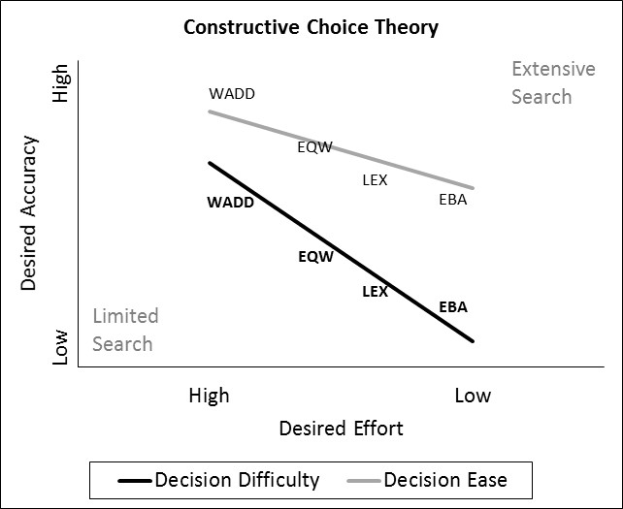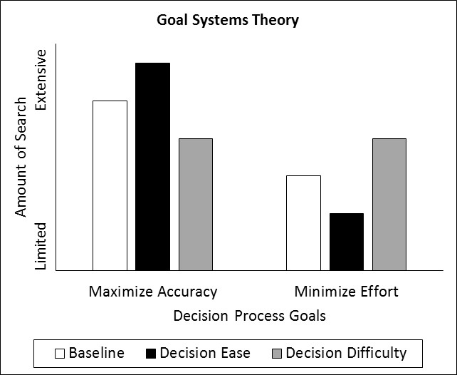
Note. – WADD = weighted adding; EQW = equal weight; LEX = lexicographic; EBA = elimination-by-aspects

Figure 1. The Influence of Decision Difficulty/Ease on Information Search in Constructive Choice Theory and Goal Systems Theory

Figure 2. Number of options considered (Experiment 1). Note.— Error bars show 95% confidence intervals.

Figure 3. Number of options considered (Experiment 2). Note.— Error bars show 95% confidence intervals.

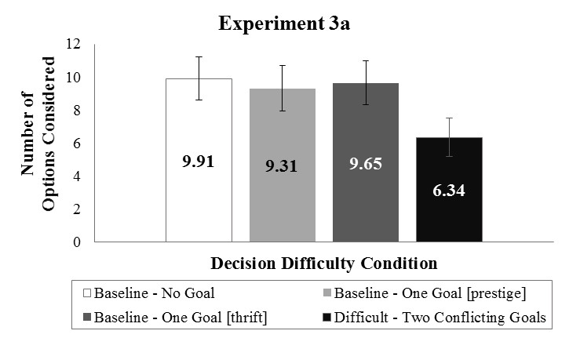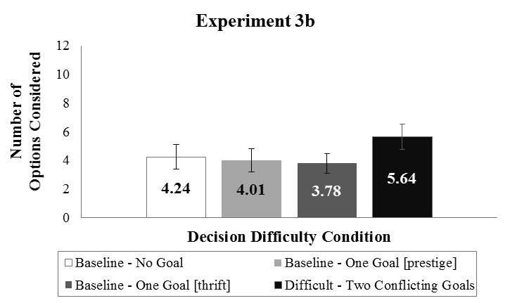
Figure 4. Number of options considered (Experiments 3a and 3b). Note.— Error bars show 95% confidence intervals

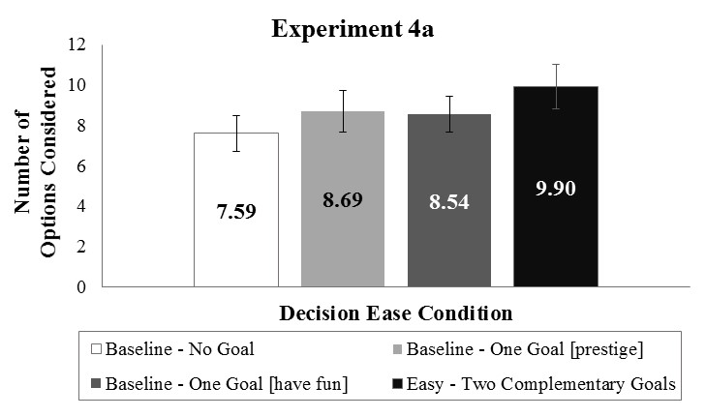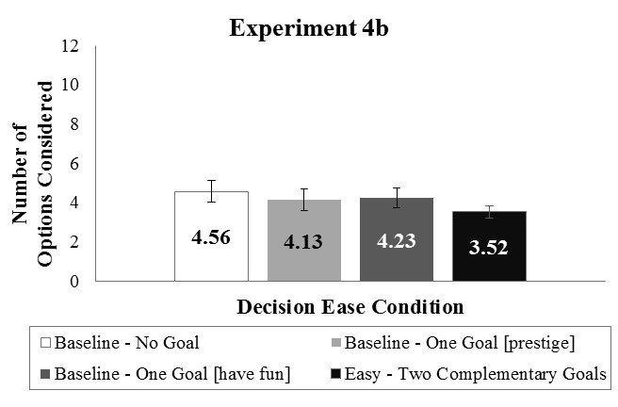
Figure 5. Number of options considered (Experiments 4a and 4b). Note.— Error bars show 95% confidence intervals.

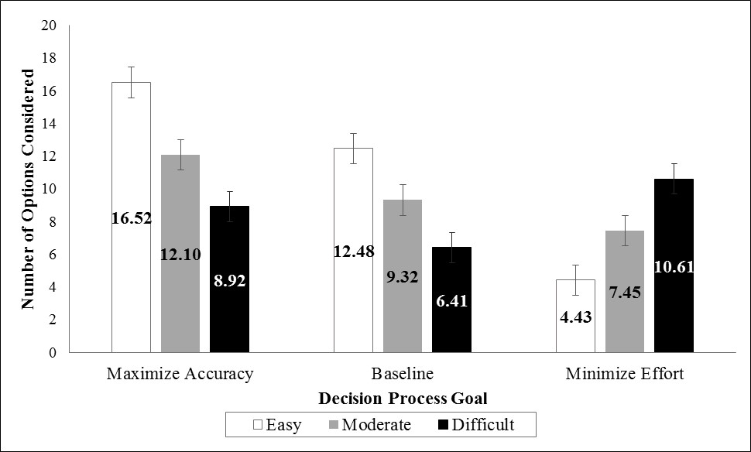
Figure 6. Number of options considered (Experiment 5). Note.— Error bars show 95% confidence intervals.

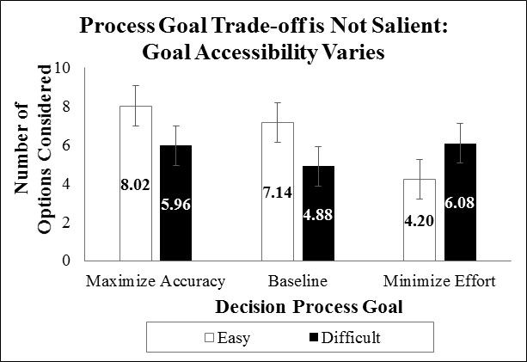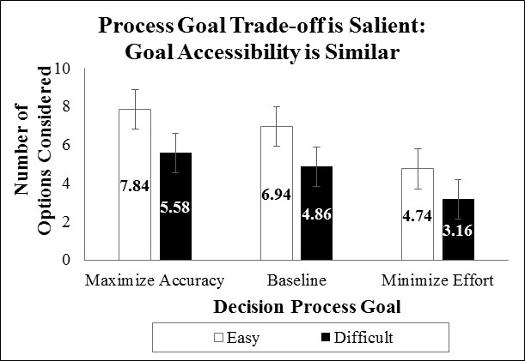
Figure 7. Number of options considered in the trade-off not salient and trade-off salient conditions (Experiment 6). Note.— Error bars show 95% confidence intervals.

